Lesson 209 – Cylindrical Joints

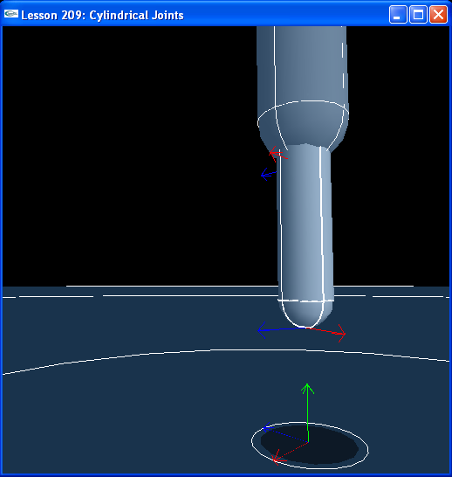

Introduction
Cylindrical joint들은 우리가 회전, 병진운동 모두를 소개하는 첫번째 jont이다. Joint된 actor들은 revolute joint 와 같이 주축에 대해서 자유롭게 회전할 뿐만 아니라 prismatic joint와 같이 주축에 대해서 병진한다.
Cylindrical joints are the first joint we introduce with both rotational and translational motion. The jointed actors are free to rotate about the primary axis like a revolute joint as well as translate about the primary axis like a prismatic joint.

Cylindrical Joints
새로운 InitNx()를 살펴보자.
Take a look at the new InitNx():

// Actor globals
NxActor* capsule1 = NULL;
NxActor* capsule2 = NULL;

// Joint globals
NxCylindricalJoint* cylJoint = NULL;
…
void InitNx()
{
capsule1 = CreateCapsule(NxVec3(0,5,0), 4, 0.85, 10);
capsule1->raiseBodyFlag(NX_BF_KINEMATIC);
capsule2 = CreateCapsule(NxVec3(0,3,0), 3, 0.5, 10);
capsule2 ->setLinearDamping(0.5);
capsule2->setAngularDamping(0.5);

NxVec3 globalAnchor = NxVec3(0,7,0);
NxVec3 globalAxis = NxVec3(0,1,0);
cylJoint = CreateCylindricalJoint(capsule1, capsule2, globalAnchor, globalAxis);

gSelectedActor = capsule2;
bPause = true;
}

Cylindrical jont의 설정은 Cylindrical joint의 생성 함수와 prismatic joint와 거의 일치한다.
The setup for the cylindrical joint is almost identical to the prismatic joint, as is the cylindrical joint creation function.

NxCylindricalJoint* CreateCylindricalJoint(NxActor* a0, NxActor* a1, NxVec3 globalAnchor, NxVec3 globalAxis)
{
NxCylindricalJointDesc cylDesc;
cylDesc.actor[0] = a0;
cylDesc.actor[1] = a1;
cylDesc.setGlobalAnchor(globalAnchor);
cylDesc.setGlobalAxis(globalAxis);

NxJoint* joint = gScene->createJoint(cylDesc);

joint->setLimitPoint(globalAnchor);

// Add up-down limiting planes
joint->addLimitPlane(-globalAxis, globalAnchor + 1*globalAxis);
joint->addLimitPlane(globalAxis, globalAnchor - 1*globalAxis);

return joint->isCylindricalJoint();
}

우리는 lower capsule의 위에 limit point를 추가하고 바닥에 평행하면서 upper actor를 가로 질러 통과하는 limit plane들을 추가한다. ‘umijkl’을 사용하여 lowe actor를 위 아래로 움직인다. ‘f’를 눌러 Force Mode와 Torque Mode로 전환하고, 여러분이 또한 lowe actor를 어떻게 회전시킬 수 있는지 살펴본다.
We add a limit point to the top of the lower capsule and limit planes that slice through the upper actor parallel to the ground. Use “umijkl” to move the lower actor up and down. Hit ‘f’ to switch from Force Mode to Torque Mode and see how you can rotate the lower actor in place as well.

Conclusion
Cylindrical joint들은 주축에 대해서 actor들이 회전하도록 하는 것만을 제외하고는 joint의 주축을 따라 병진하는 prismatic joint들과 아주 비슷하다.
Cylindrical joints are very similar to prismatic joints with the exception that the actors are allow to rotate about the joint’s primary axis as well as translate along it.

Related Classes, Functions, and Parameters
NxCylindricalJointDesc
NxCylindricalJoint

